Phalanges
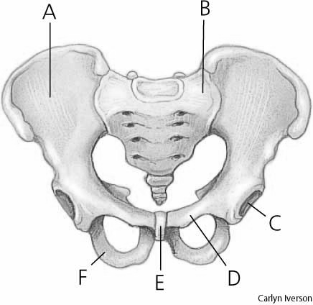
Metatarsals
Tarsals
Sacrum
Coccyx
Os Coxa
Epiphysis
Femur
diaphysis
Fibula
Tibia
Pubis
Ischium
Ilium
Patella

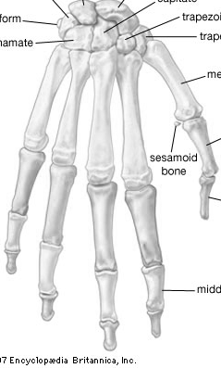
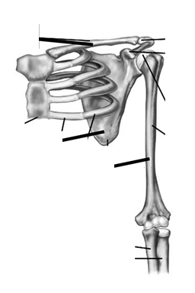
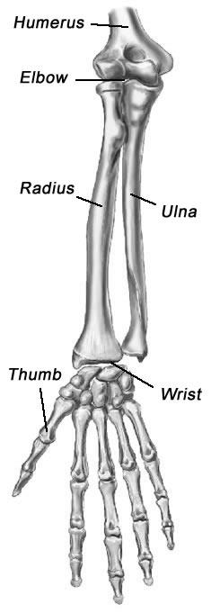
Radius
Ulna
Clavicle
Scapula
Humerus
Phalanges
Metacarpals
Carpals

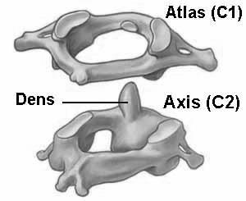
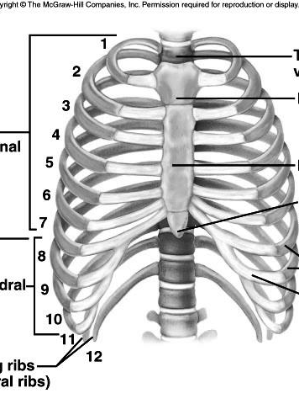
Atlas
Axis
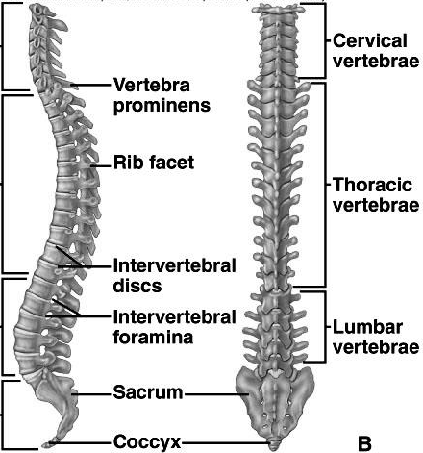
Cervical
Thoracic
Lumbar
True Ribs
False Ribs
Floating Ribs
Sternum

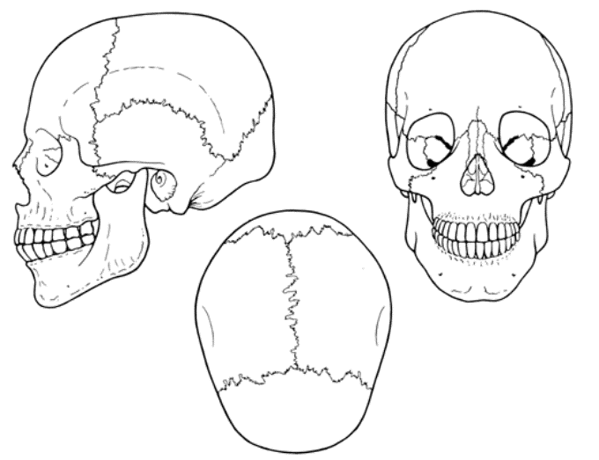
Frontal Bone
Nasal Bone
Maxilla
Mandible
Zygomatic
Temporal
Squamosal Suture
Parietal
Occipital
Lambdoidal
Sphenoid
Sagittal
Coronal

